

**Harmeny Athletic Club**

**Trustees’ Annual Report**

September 2022-August 2023

**Charity Contact information**

Harmeny Athletic Club

Scottish Charity Number: SC048917

10 Kirkgate  
Currie  
Edinburgh

EH14 6AN

[secretaryharmeny@gmail.com](mailto:secretaryharmeny@gmail.com)

Website harmenyac.org

**Charity Trustees -**

1. Susan Ross - Chairperson
2. Mairi Wallace - Treasurer
3. Susan Irwin - Secretary
4. Craig Stewart – Junior Section
5. Nicola McGuire – Membership Secretary
6. John Pringle – Board Member
7. Dougie Porteous – Vice Chair and Runners Council rep
8. Phil Holden – Board Member
9. Hin Lee – Board Member

**Objectives and activities**

The Club will operate as a non‐profit distributing charity whose principal objectives are:

* The advancement of public participation in Athletics as a sport;
* To provide recreational facilities and/or organise recreational activities, available to members of the public at large, with the object of improving the conditions of life;

In furtherance of the above shall:

* Provide a base for successful competitive track and field athletics and country running and to develop the full potential of each member.
* Encourage   enthusiastic   instructors, coaches, officials   and administrators   within   the   club   and   provide   opportunity   for qualification and experience; and
* Provide a base for non‐track and field runners and those wishing to run as a recreational activity or to improve their general fitness.

**Structure, governance and management**

Type of governing document

In 2018 the club members voted to accept a new club constitution which had been written with the support of a Scottish Athletics funded lawyer. In parallel to this, the club applied to the OSCR to become a Scottish Incorporated Charitable Organisation (SCIO). The application was accepted on 9th December 2018.

The Board of Trustees currently numbers 9. The constitution allows for between 5 and 12 members. The core roles of the Board are: Chairperson, Secretary and Treasurer. The Board also currently contains a Vice Chair and Membership Secretary plus 2 other Board members.

The affairs of the running sections are overseen by the Runners Council consisting of an Adult Runner’s Rep and Junior Section Rep.

In August 2023, a new sub-committee was constituted as per clauses 105-109 of the Harmeny constitution.  The ‘Facilities’ sub-committee was created in order to discuss and negotiate all matters with regards to the improvement of track facilities for the club and especially the proposed special purpose vehicle (‘SPV’), which would involve Harmeny, to take on a long-term lease of Saughton enclosure.  It was agreed that this sub-committee would be created, and Nicola McGuire and Craig Stewart would represent and report to the board on progress at each board meeting, and more regularly where required.  The proposal is that the sub-committee should have delegated authority up to £2,000 in line with other delegations to the junior and senior sections of the club.  All decisions that would have a higher financial, reputational, or contractual impact on the club would continue to be brought back to the board for agreement.

**Trustee recruitment and appointment**

Phil Holden and Hin Lee were asked to join the Board of Trustees in May 2023.

Angela Lawson and Naomi Head are the Welfare Officers for the Club but have chosen not to take a place on the Board of Trustees.

**Achievements and performance**

2022-23 Report Stated Priorities

**Coaching**

In our 2022-23 report, we stated that we wanted to continue the return to ‘normal’ after covid restrictions were lifted following a successful commencement of activities in 2022.

This was, in part, achieved as we once again engaged with the Active Schools (Edinburgh) team, delivering in 6-week blocks to six different primary schools in the Firhill and Forrester clusters. We have also re-launched a new run, jump and throw group at Saughton on a Thursday which is preceded by a new session for S1 pupils at Wester Hailes High School.

However, in common with many industries post-covid, recruitment continues to be an issue for Harmeny. A coaching officer role has been advertised 4 times throughout the year and no applicants have come forward.

We have been fortunate to have some excellent young athletes help with younger groups which has meant we have kept good numbers in our earlier, younger sessions. Some have now left us to go to university in other cities, but we have also managed to recruit students from Heriot-Watt university to help out.

However, the overall impact of the lack of recruitment of experienced coaches means that we continue to struggle with clearing the waiting list which sat at over 150 kids in early August, with some older kids (12+) having waited for over 2 years for a place. We will seek to address this again in 2023-24.

**Facilities**

Progressing a project to improve the facilities at Saughton has proven to be slower than expected. However, in August, the 3 clubs who have a vested interest in the project came together to sign a Memorandum of Understanding – a non-legally binding document that sets out key objectives and how the clubs intend to work together to achieve these. Harmeny now have a sub-committee formed to help progress various aspects of the project and this subject will be covered in more detail later.

**Competition**

The final objective stated last year was to get more athletes engaged in competitive athletics. Specifically, we have been very active in selling the merits of these but have also been able to provide more opportunities than ever.

* We entered a team into the Youth Development League Lower for U13 and U15. We did unexpectedly well in this league, narrowly missing out on winning division 2 at the first attempt.
* 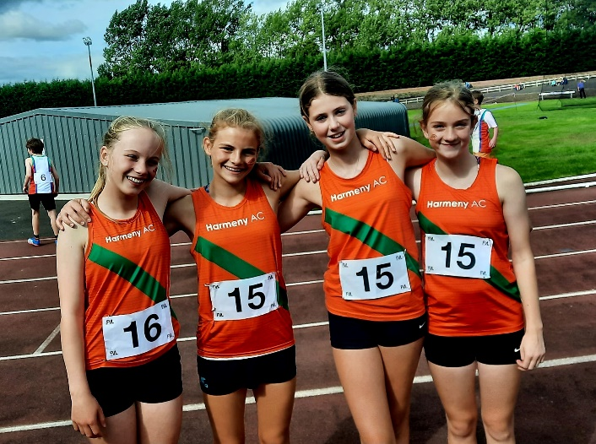We had teams in the new Scottish National Athletics league, which has given opportunities to U17/U20/Seniors which I’m pleased to say they have been eager to take up, with the U17 girls team doing particularly well, claiming 6th place nationally.
* We co-hosted the new Regional Superteams at Saughton which gave younger athletes their first taste of competitive athletics in a familiar setting.

There are still gaps and how we seek to address these will be covered later.

**Providing performance platform for older juniors**

We identified that, as the success and the age profile of our athletes grows (in 2015 we had 35 athletes in the U15 or older age categories, in 2023 it’s 116) their coaching time demands, especially in the technical events, grows. We have provided them competitive opportunities, but finding the coaches with the time and knowledge continues to be a struggle.

The wide range of events in which we have won medals in 2023 is a testament to the coaches as well as the athletes and is an indication of success in this objective. However, the demands will continue to grow, and we still need to face into the challenges in the coming year.

**Off-field Achievements**

With a greatly expanded number of competitors, we’ve recognised we have an obligation to support the sport as a whole by providing officials: we now have 9 qualified (level 1/2) officials, plus 6 ‘in training’ including one volunteer on the road to becoming a qualified starter.  Finally, during the Easter holidays, we had the Scottish Athletics officials team visit us to educate 16 under-16s to become Assistant Officials, a number of whom have now completed their experiences at various league meetings.

We also now have 3 Level 2 officials in the club and a starter’s assistant learning the ropes of the red hat!

As well as taking part in our usual annual competitions, the club once again organised a large number of events, keeping the appetites of our members and the local athletics community sated. These included:

* 7Reservoirs Half Marathon – despite challenges that have caused the cancellation of other events, the best half marathon in Scotland returned for it’s 10th edition and is due for its 11th in December.
* 7Reservoirs Virtual – the popularity of this race during the pandemic meant it has continued into 2022 and 2023.
* Harmeny Vs CAAC cross country match – returned to its traditional home in September, acting as the traditional XC season opener for young athletes.
* Super Saturday – encouraging our new junior members into athletics events in a local, friendly way which, for many, was their first taste of competition post-covid
* Under 12 SuperTeams – the first time a Scottish Athletics event has been hosted by Saughton, with help from Harmeny and our friends at CAAC.
* Water of Leith Handicap race for club members returned on a very hot day in September.
* Rigg Race – the Lothians’ oldest road race, catering for Balerno’s local community as part of the Children’s Gala week.
* HAC Club Champs – becoming a fixture in the early September slot, with more qualified officials helping each year and a hope to make a fully licensed event in 2023 and a Level 1 licensed event in 2024.

**Membership Statistics**

There has been a steady increase in the number of senior members joining this year, up 3% over prior year, offsetting those that have left due to family commitments or moving out of the area. We continue to see new member interest generated by word of mouth and offer some taster sessions before requesting fee payment and access to our Facebook page.

There has also been a steady increase in the number of Juniors joining us, up 5% over prior year. Our ability to grow the junior membership is dependant on availability of additional Level 1, 2 and 3 coaches.

|  |  |  |  |  |
| --- | --- | --- | --- | --- |
| **Membership Group** | **2022/23** | **2021/22** | 2020/21 | 2019/20 |
| **Members** |  |  |  |  |
| Senior members | 241 | 236 | 210 | 201 |
| 2nd claim | 3 | 3 | 4 | 3 |
| Active Junior members | 205 | 195 | 218 | 188 |
| Inactive Junior members (left during the year) | 86 (not included in total) | 133 (Not included in total) | 77 (Not included in total) | 55 (Not included in total) |
| **Total** | **449 (up 3%)** | **434 (up 5%)** | **432 (up 10%)** | **392 (up 14%)** |
|  |  |  |  |  |

Our coaching, officials and helper community continues to grow, with continued commitment from coaches and officials to gain additional levels of qualification over time. Some of our junior athletes have also committed their time this year to qualify as Assistant Officials and give time at events in addition to their training and racing commitments.

|  |  |  |  |  |
| --- | --- | --- | --- | --- |
| **Coaches & Officials** | **2022/23** | **2021/22** | **2020/21** | **2019/20** |
| Level 3 (Event Group) | 7 | 6 | 6 | 4 |
| Level 2 (CIRF) | 7 | 6 | 4 | 7 |
| Level 1 (Coaching Assistant) | 13 | 15 | 11 | 8 |
| Jog Scotland Leaders | 10 | 11 | 12 | 12 |
| Jog Scotland Volunteers | 9 |  |  |  |
| Other/Helpers | 22 | 14 | **6** | **8** |
| Officials – Qualified | 11 | 7 (plus 3 pending qualification) | **9** | **2** |
| Assistant Officials | 5 | 3 | **7** | **6** |
| Assistant Officials (Junior) | 16 |  |  |  |

The table below shows the spread of athletes by gender and age group. For our 2022/23 junior members, we have 47%/52% split of Male to Female athletes. We have a good spread of juniors across the age groups, peaking at U13.

|  |  |  |  |  |  |  |  |  |
| --- | --- | --- | --- | --- | --- | --- | --- | --- |
| **2023** | **U9** | **U11** | **U13** | **U15** | **U17** | **U20** | **U23** | **Total** |
| Male | 11 | 17 | 28 | 19 | 15 | 6 | 2 | 98 |
| Female | 13 | 22 | 32 | 22 | 15 | 1 | 2 | 107 |
|  | **24** | **39** | **60** | **41** | **30** | **7** | **4** | **205** |
|  | 11.71% | 19.02% | 29.27% | 20.00% | 14.63% | 3.41% | 1.95% |  |

**Junior on-field achievements**

**Off-Track (Cross Country, Road, Hill and Trail)**

There have been some fantastic off-track performances from Scottish clubs this year and our members have been inspired by them all. Winning the U15 boys Lindsays National XC, the culmination of many years of hard work by the athletes and club was a cause for much celebration – and cost coach Andy Ross a ‘cheeky Nandos’ for the whole team!

The Harmeny xc season always starts with our friendly xc match with Corstorphine AAC where we encourage members and their friends to join us in early September for some fun xc running. It’s local and low key.

Our main competition pathway is the East District League, and you can see from the graphs that we have shown an impressive increase in participation over the last few years and we’ve also seen a big improvement in our performances winning our first ever trophy in 2016 and going on to collect 10 further wins and many second places. We’ve also fielded our first ever full male and female teams in 2022/23. Improvements like these only happen with the dedication of our coaches and helpers who go the extra mile every week, encouraging members to take part and making sure they feel equipped to take on the challenge.

As well as cross country, we’ve also had members racing over hills and trails, with national champions and Scotland selections aplenty.

**Scottish Mid-Trail Championships**

U15 Girls Gold - Nancy Corrie

U15 Boys Bronze - James Wotherspoon

U13 Girls Silver – Carys Melton

U15 Boys Gold - U15 Boys, James Wotherspoon, Dair Alexander, Daniel McIntyre.

**East district relay XC Championships**

Junior Males Bronze (Harry White, Fergus Ross, Finlay Ross)

**Scottish Short Course XC Championships**

U15 Team Silver (Matthew Holden, Kieran Hardie, Fergus Ross)

U17 Team Bronze (Alasdair Wallace, Finlay Ross, Ethan Lorimer)

U20 Male Bronze – Tendai Nyabadza

**East District XC Championships** -

U15 Girls Team Bronze – Natsai Nyabadza, Nancy Corrie, Georgie Bruce

U15 Boys Team Silver – Kieran Hardie, Dan McGuire, Fergus Ross

13 Selections for East of Scotland representation at Inter District Championships:

U13 Girls: Rachel Caves

U13 Boys: Harry White, Lorcan Morrison

U15 Girls: Natsai Nyabadza, Nancy Corrie

U15 Boys: Kieran Hardie, Dan McGuire, Fergus Ross, James Wotherspoon, Dair Alexander, Sam Beattie

U17 Boys: Ethan Lorimer, Alasdair Wallace

**East District league**

U11 Boys ESH Cup Winners

U15 Boys - Edinburgh Evening News Cup Winners

**National XC**

U15 Boys Team GOLD (James Wotherspoon, Dan McGuire, Matthew Holden, Kieran Hardie)

**Young Athletes Road Races**

U15 Boys Team Silver - Dair Alexander, James Wotherspoon, Kieran Hardie

U15 Girls Team Silver - Natsai Nyabadza, Nancy Corrie, Georgia Bruce

**InterCounties XC Loughborough**

East of Scotland Selection –Natsai Nyabadza, James Wotherspoon, Kieran Hardie and Alasdair Wallace

**SIAB XC**

Fergus Ross – Silver, medley relay

**London Mini Marathon**

Team Scotland Selection – Natsai Nyabadza

**British & Irish Junior Hill Running Championships (inc. the Junior Home International)**

Kieran Hardie - Scotland selection

James Wotherspoon – Scotland selection

Dan McGuire – Scotland East selection

**Lomonds of Fife Hill Race**

U17 males Dan McGuire Silver

**Dumyat Junior race**

Rory Beattie gold u13b

Dan McGuire gold u17m

James Wotherspoon Bronze u17m

**Lomonds junior hill race**

Rory Beattie gold u13b

Dan McGuire silver u17m

**Cornalees Hill race**

Dan McGuire Bronze u17 men

**Gala Harriers Eildon Hill Race**

Dan McGuire Gold

James Wotherspoon Bronze

**The Cademuir Rollercoaster**

Kieran Hardie bronze u17 men

**Track & Field**

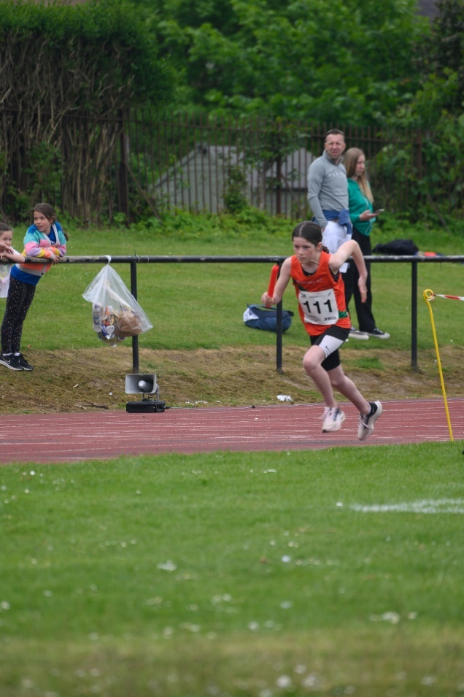This year felt like a coming of age for the club as a competitive track and field club.  Just 6 years ago our only T&F league entry was to the Forth Valley League, but this year saw us offering our athletes an opportunity to experience competition at every age group and every stage of development, from under 11 to Seniors: Starting with hosting “SuperSaturday” (an open event for club members and local Active School groups with sprints, middle distance, throws and jumps) to give young athletes a taste of competitive athletics, we now have teams entered into Scottish Athletics Indoor League (SAIL), a second team in the Forth Valley League and this year for the first time, entry to the YDL-Lower (where we finished 2nd in Div 2) and the Scottish National Athletics League.  SNAL has proved to be a good opportunity for our senior athletes. We have had some masters success too with a gold in the Masters Open and a bronze in the UK champs. This has resulted in a record number of our athletes competing in the Harmeny colours – 116 in total over the summer season!!!

In National and District championships, we’ve seen a record number of entries from Harmeny once again: over 40 Harmeny athletes competed at Grangemouth in the East District champs in May with 18 medals won in a diverse range of events (more than tripling our previous record haul):

* Javelin (1 gold, 2 silver),
* shot putt (1 gold, 1 bronze),
* discus (1 gold), long jump (1 bronze),
* hurdles (1 silver),
* 100m (1 gold, 1 bronze),
* 200m (2 bronze),
* 800m (1 gold, 1 silver, 1 bronze),
* 1500m (2 silvers, 1 bronze).

Harmeny also won a silver and a bronze in the track relay champs and finished 4th in the u12 Superteams, having co-hosted the regional event at Saughton in June.  Last but not least, we have fielded our first combined eventer in the recent National champs, and now have a handful of athletes competing in steeplechase, including the bronze medallist at the recent SIAB international.

**National Indoor Masters Championships**

M35 800m Silver – Phil Holden

**Scottish schools Indoor Championships**

U15 300m – Gold – Georgie Bruce

**Scottish Athletics Indoor Championships**

U15 300m – Gold – Georgie Bruce

U20 Triple Jump (Bronze) - Tsz Yau (Evana) Chan (still an Under 17!)

**East District championships**

U17W Bronze - Ella Jones – 100m

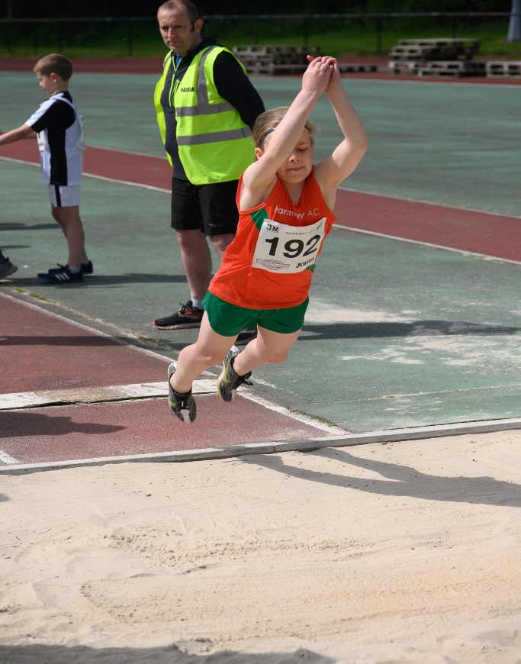U17W Silver - Ella Jones – 80m hurdles

U15B Gold – Alex Columbine-Green – 100m

U15B Bronze – Alex Columbine-Green – 200m

U15G Silver – Georgie Bruce – 800m

U13G Bronze – Holly Finlayson – Long Jump

U15G Gold – Alex Waterston-Law – Shot putt

U17W Bronze – Esther Taylor – Shot putt

U15B Gold – Daniel McIntyre – 800m

U15G Silver – Olivia Lee – Discus

U13B Bronze – Josh Lee – 200m

U13B Silver – Josh Lee – Javelin

U15B Bronze - Fergus Ross – 1500m

U13B Silver -Rory Beattie – 1500m

U15G Bronze – Nancy Corrie – 1500m

U17W Silver – Natsai Nyabadza – 1500m

U13G Gold – Anya MacDonald – Javelin

U13G Silver – Maya Buchan – Javelin

**Scottish Schools T&F**

U15B Silver Fergus Ross – 800m

U17B Silver Matthew Holden – 1500m Steeplechase

**European U20 Championships Jerusalem**

Team GB Selection – 1500m - Tendai Nyabadza

**SIAB T&F International**

Scotland selections & Bronze Medal Matthew Holden 1500m Steeplechase

**National Track Relay Championships**

U15 Boys Silver 3x800m – Dair Alexander, Fergus Ross, Matthew Holden

U15 Girls Bronze Medley – Olivia Muir, Leah Buchan, Nancy Corrie, Georgie Bruce

**National Masters Championships**

M35 800m Silver – Phil Holden

**BMAF - British Masters AF Track & Field Championships**

M35 1500m Bronze – Phil Holden

**Club Awards** (2022)

Male Athlete of the Year: Ethan Lorimer  
Female Athlete of the Year: Nancy Corrie  
Best Performance Combined Event/Field: Esther Taylor  
Best Performance Endurance: Finlay Ross  
Best Performance Sprint: Euan Laird  
Endeavour Award: Keiran Hardie

**Records**

League Records:

**Scottish National Athletics League**

Ella Jones – 80m hurdles

Fraser Holman – 5,000m

Natsai Nyabadza - 3,000m

Scottish Indoor League

Blake Burchill – 600m

**Club Records (62):**

Under 11 Girls:

Cadha McLuskey 75m - 11.45s

4x 100m 64.4s - Zoe Coull, Andrea Scott, Ava Whyte, Luciana Starkey

Under 13 Girls:

Lois Hills 75m – 11.32s

Eve Bogie 150m – 22.58s

Carys Melton – 1mile – 5.40.64

Under 15 Girls:

Georgie Bruce 300m – 42.45s (Indoor)

Nancy Corrie 1 mile – 5.18.38

Under 17 Girls:

Ella Jones 80m hurdles – 12.29s

Ella Jones 100m – 13.13s

Ella Jones 60m hurdles (Indoor) 10.11s

Ella Jones 200m – 27.73 (Indoors)

Lara Brechin 300m – 44.90s

Lara Brechin 300m – 44.90s (Indoors)

Lara Brechin 800m – 2.35.27

Natsai Nyabadza 800m – 2.18.58

Natsai Nyabadza 1500m – 4.36.91

Natsai Nyabadza 1 mile – 4.55.32

Natsai Nyabadza 3000m – 10.29.2

Skye Marshall 1500m Steeplechase – 5.58.09

Tsz-Yau Chan Long Jump – 4.88m

Tsz-Yau Chan Triple Jump – 10.50m (indoors)

Tsz-Yau Chan Long Jump – 4.99m (indoors)

Esther Taylor Javelin – 19.58m

Esther Taylor Shot Putt – 8.82m

Esther Taylor Pentathlon – 2472pts

Esther Taylor Pentathlon – 2401pts (indoors)

Esther Taylor Heptathlon – 3219pts

Esther Taylor High Jump – 1.45m (indoors)

4x100m – Y Chan, E Taylor, E Jones, E Scobbie – 53.7

4x400m - E Scobbie, N Nyabadza, S Marshall, E Taylor – 4.39.57

**U20 Girls**

Lucy McDonald Long Jump 4.13m (indoor)

Lucy McDonald Long Jump 3.99m

Non-Track

Parkrun JW15-17 Skye Marshall 20m 51s

Parkrun JW11-14 Nancy Corrie 18m45s (also an overall club record)

**Boys:**

U11 Boys

Blake Burchill 60m – 8.84s

Blake Burchill 60m – 8.97s (Indoor)

Blake Burchill 150m – 22.28s

Blake Burchill 200m – 30.21 (Indoor)

Blake Burchill 300m – 37.16

Blake Burchill 500m – 1.28.64

Blake Burchill 600m – 1.44.84

Blake Burchill 600m – 1.46.87 (indoor)

Blake Burchill 1500m – 5.08.4

Blake Burchill 1 mile – 5.30.00

Blake Burchill Long Jump – 4.05m (indoor)

Blake Burchill Shot Putt – 6.56m (indoor)

Blake Burchill Standing Long Jump – 1.92m (indoor)

4x200m - R Bullock, B Silver, B Burchill, C Burchill 2.11.9 (indoor)

U13 Boys

Rory Beattie 75m – 11.73s

Josh Lee 200m – 21.75s

U15 Boys

Fergus Ross 800m 1.57.98

Fergus Ross 800m 2.02.2 (indoor)

Daniel McIntyre 1500m 4.24.23 (indoor)

U17 Boys

Euan Laird 200m 23.85s (Indoor)

Euan Laird 200m 23.56s

Euan Laird 400m 53.17s (Indoor)

Matthew Holden 1500m 4.12.86 (Indoor)

Kieran Hardie 1 mile 4.34.23

U20 Boys

Finlay Ross 800m – 1.54.21

Tendai Nyabadza 1500m – 3.41.71

Non-Track

Parkrun JM15-17 Kieran Hardie 16.06 (also an overall club record)

Junior Parkrun JM10 Blake Burchill 6.57

**Adult Achievements**

The past year has been the first full year post pandemic of normality. Club runs, events, track and hill rep training sessions have all taken place alongside an informal Wednesday walking group. Attendances have remained strong throughout the year with something on offer throughout atypical week for everyone.

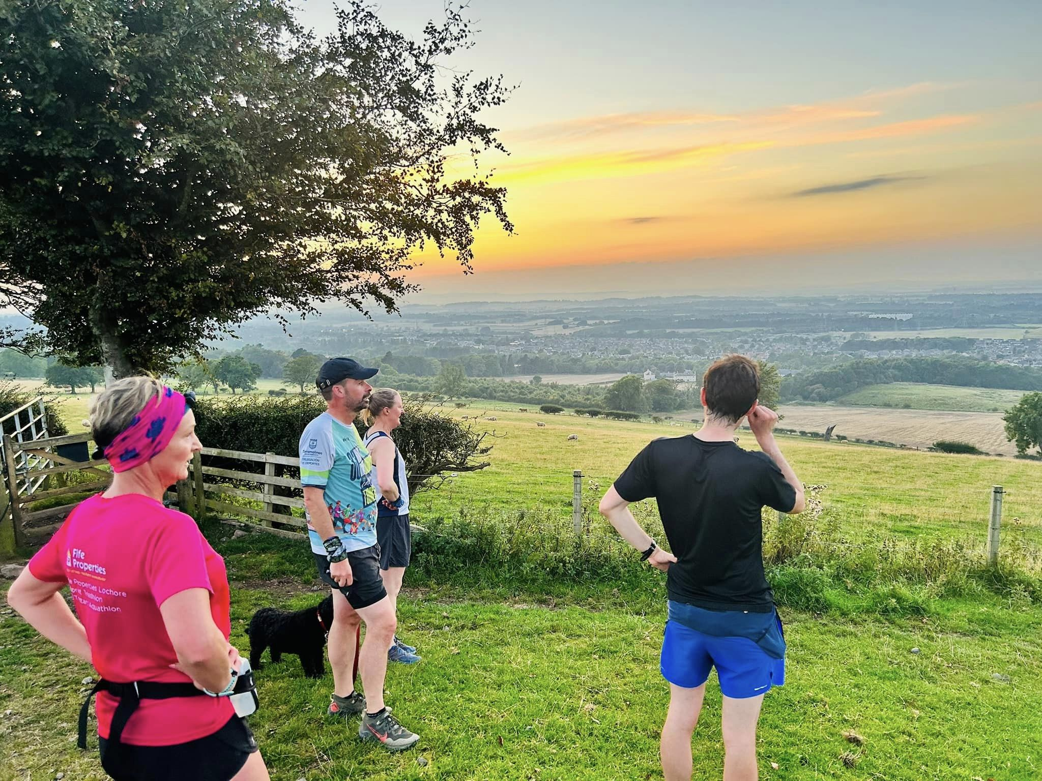

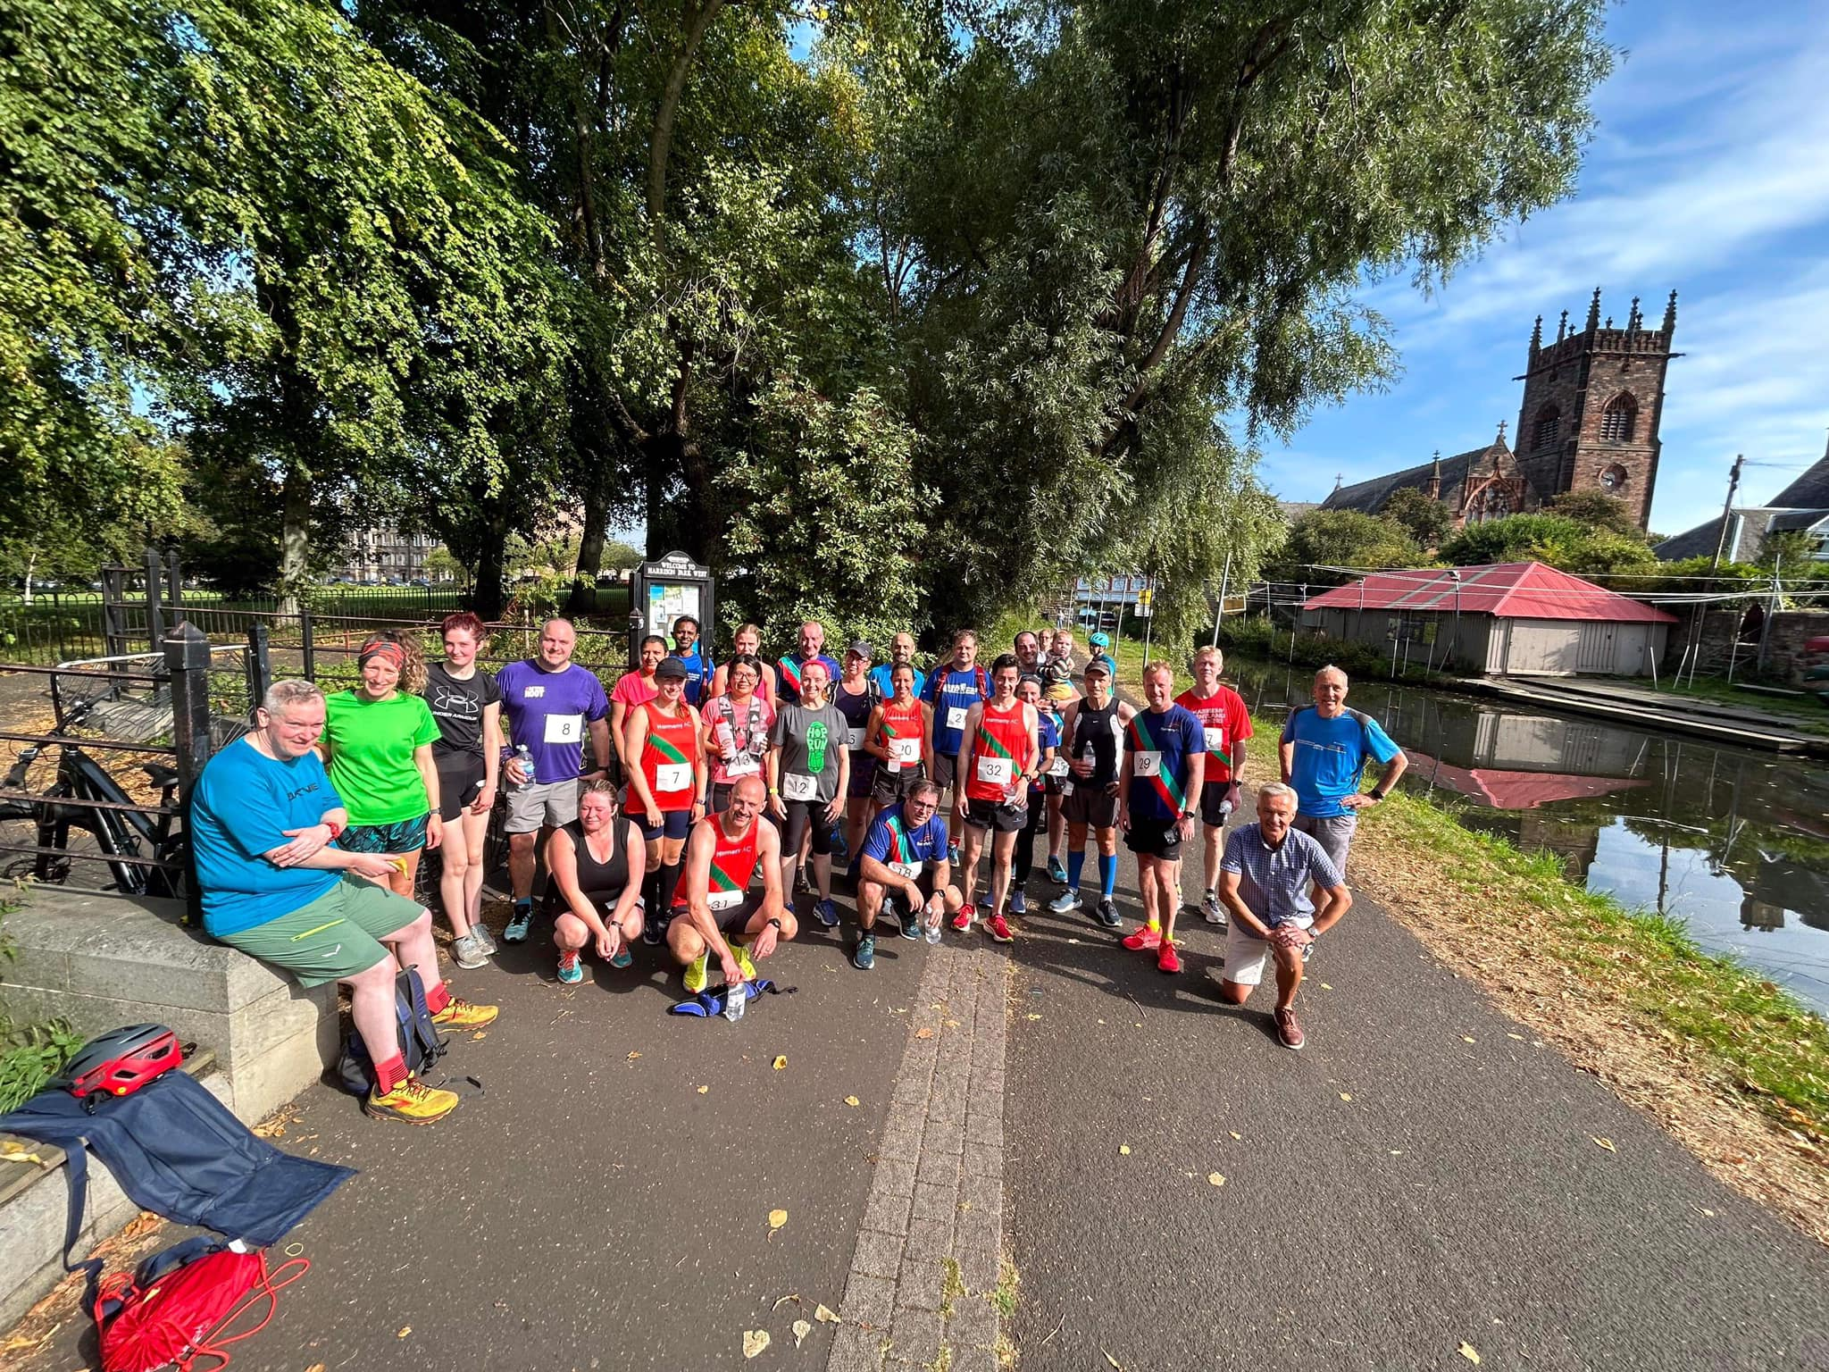

**Performance**

Fastest times over recognised distances:

Marathon – Male – Damien O’Looney- 2:40:34 (Berlin- September)

Marathon – Female – Karen Robertson – 3:14:59 (Boston- April)

Half Marathon – Male – Ross Millar- 1:17:54 (Torremolinos- February)

Half Marathon – Female – Karen Robertson- 1:33:01 (Scottish Half- September)

10k – Male – Phil Buckley- 35:44 (Round the Houses- April)

10k – Female – Corrie Roberts – 40:31 (Wild Deer, Dalkeith- October)

5k – Male – Ross Millar- 17:15 (Edinburgh Park Run- September)

5k – Female – Karen Robertson – 20:58 (Edinburgh Park Run- January)

**Ultra Running Achievements**

Our club members have had a number of achievements in ultra-marathons over the year and a full download of their results and those from previous years can be found at:



A huge thank you to Donald Sandeman for keeping track of all of the ultramarathon results and Darren Cavaroli for tracking the club performances. There are too many amazing achievements to mention with our members competing across Scotland, the UK and the World. Lots of age category wins and top 10 placings firmly putting Harmeny on the running map!

**Grand Prix Event**

The 2023 Grand Prix has been going well with Karen Robertson leading the way in the Female Races and Phil Buckley leading the way on the Male Grand Prix. There are 2 races remaining in the schedule with options for everyone to run their fastest 5k, 10k, Half or Full Marathons.

**Rigg Race**

140 runners took part in the race and great showings from Craig McBride in 9th, Ewan Mitchell in 19th, Lewis Kemp in 21st, Drew Nutsford in 34th, Keith Martin in 43rd, Heather Simpson in 58th, Graham Tennet in 62nd, Martin Lyall in 119th and Helena Mackay in 133rd. Huge thanks to everyone who volunteers to put this on and particularly to Steven Brown the Race Director.

**7Rs**

97 runners made their way round the tricky 13.1 mile course in early December. Some great runs from the 10 club members who took part. A huge thank you to Donald Sandeman the Race Director and all our volunteers. The 2023 event has proved a little trickier to progress after land access issues in the Pentlands which has affected other local running events with the iconic Skyline Race being cancelled for 2023. However, all the appropriate permissions have been secured for 2023 and Rachel Shannon and Dougie Porteous will share the Race Director duties.

**Club Handicap Race September 2022**

Another very successful and well attended Club Handicap Race on September 10th with 26 club members tearing down the Water of Leith and along the canal to Harrison Park. Well done to all who took part and in particular to 1st male Alistair Mackenzie and 1st female Meenakshi Jeyeraman. Fastest male was Lewis Kemp and fastest female was Rhona Scott Many thanks to John Pringle for organising the event and all of the volunteer marshals and timekeepers.

**Cross Country**

The club saw some fantastic turnouts and performances across all the National and East District events from October to February. So good to have cross country back and the buzz of running for the team. The new season will soon be upon us and it will be great to see as many people get along as possible.

 Dates as follows:

7th Oct – East District Relays – Livingston

21st Oct – National Relays – Cumbernauld

4th Nov – National Short Course - Lanark

2nd Dec – East District League – Aberdeen

13th January- Inter-District Championships- Renfrew

11th February- National Masters Championship- Forres

24th February- National Championship- Falkirk

14th March- Scottish Disability Championships- Glasgow

**Jogscotland**

Our JogScotland programme faltered a little in the last year and we are looking to re-establish it during 2023/24. It’s been such a success for encouraging new members to the club and we hope we can find the volunteers from within the club to sustain a couple of intakes per year.

**Training**

Club training has very much got back to normal this year and the club is continuing to offer a variety of runs each week.

Many thanks to Nicky Freedman and Darren Cavaroli for their fun and enthusiastic Thursday track sessions. A special thanks to Nicky who has moved South and will no longer be able to coach and a big thanks to Adam Irving for stepping in to support Darren from here.

Sunday runs have been growing well with 4 groups now meeting every Sunday at 9.30am. Many thanks to the core group of members who have proposed some great routes.

Wednesday night runs and headtorch runs have also been very well attended and again huge thanks to all those who have been helping organise them.

Finally, a huge thank you to all of our members who have contributed over the last 12 months and supported one another. Harmeny really is a fantastic club, and the members make it so. I’m sure I’m not alone in saying that getting together on our club runs, be it on the tarmac or in the hills, is not only fun but gives us all a great sense of wellbeing and happiness.

**Thanks!!!**

Many thanks once again to the incredible number of volunteers (well over 100!!!!) and coaches who, together, make Harmeny the incredible club that it is…

|  |  |  |  |  |  |  |  |  |  |  |  |  |  |  |  |  |  |  |
| --- | --- | --- | --- | --- | --- | --- | --- | --- | --- | --- | --- | --- | --- | --- | --- | --- | --- | --- |
| **Junior Coaching**  Derek Johnstone  Lorraine Halcrow  Andy Ross  Stephen Buchan  Phil Holden  Pam Lorimer  Graeme Stewart  Craig Stewart  Jonathan Kennedy  Grainne Morrison  Marco Lam  Ethan Lorimer  Beth Campbell  Kim Wilson  Liam Clark  Nicky Freedman  Kevin Kealy  Sophie MacGillivray  David Alexander  Allan Hardie  Mike Taylor  Louise McKay  Callum Gladwin  Euan Laird  Sam Beattie  Ellie Morrison  Esther Taylor  Ian Kennedy  Toni Clarke  Anne Currie  Gareth Denny  Cameron Weir  Dan McGuire  Gail Burchill  Andrew Finlayson  Fraser Holman  Adam Irving | **Senior Coaching**  Darren Cavaroli  Nicky Freedman  Adam Irving  **Jog Leaders**  Kim Anderson  Adrian White  Anne Douglas  John Pringle  Jackie Pringle  Elaine Sandeman  Anne Enneguess  Martin Lyall  **Website, SAL, Club Records, Race Results, Welfare, Waiting List**  Susan Ross  Chris Haworth  John Smith  Angus Kay  Ian Smith  Darren Cavaroli  Donald Sandeman  Karen Marshall  Lesley Rowand  Angela Lawson  Naomi Head  Sarah Corrie  **Photography**  Mike Taylor  **Adult Race/Event Directors**  Donald Sandeman  Steven Brown  John Pringle | **Officials**  Nick Green  Lyndsay Holden  Karen Marshall  Susan Ross  Lorraine Boyd  Sarah Corrie  Joe Melton  Stephen Buchan  Stephen Burchill  Anja Louca  Dave Law  Lorraine Halcrow  Carole Hardie  Mike Walker  Hin Lee  Lesley Rowand  Craig Paul  **Junior Officials**   |  | | --- | | Lara Brechin | | Meda Reivytis | | Dair Alexander | | Georgia Bruce | | Halszka Musialowicz | | Alex Columbine-Green | | Jemma murray | | Ewan Mitchell | | Daniel McIntyre | | Iona Kealy | | Nancy Corrie | | Leah Buchan | | Olivia Lee | | Skye Marshall | | Natsai Nyabadza | | **Adult Run Arrangers**  Elaine Walker  John Pringle  Dougie Porteous  Paul Campbell  Phil Buckley  Kim Anderson  Donald Sandeman  Elaine Sandeman  Pam Williams  David Syme  Kirsty Stoddart  Colin Davidson  Allan Stratford  Hannah Walsh  Anne Douglas  Jon Waters  **Team Management**  Mike Taylor  Nick Green  Susan Ross  David Alexander  Stephen Buchan  Gail Burchill  **Board**  Susan Ross  Phil Buckley  Nicola McGuire  Dougie Porteous  John Pringle  Craig Stewart  Mairi Wallace  Susan Irwin  Hin Lee  Phil Holden |

Special thanks to Mike Taylor, who not only contributes countless hours to the club through coaching and photographing but is also contributing all proceeds from sales of his photos to club funds. Many thanks Mike!!!

**Financial review/Treasurer’s Report**

A full, audited set of accounts to be completed with the club’s end of year report for the

OSCR.

The accounts have been prepared in a Receipts and Payments Basis (no accruals). Income

and payments are accounted for at the time of presentation.

In summary, last year’s accounts to August 2022 showed a surplus of £9,781. This year we

have a deficit of £1,592. The bank balances are still at a healthy £59,282 at this year-end.

Receipts down circa £4K

* This is partly due to the fact that there was a temporary reduction in the annual

membership fees from £25 to £10 to help with the cost-of-living crisis which works

out at approx. £7k had it been £25/pp. If full fees had been charged, we would broke even. The annual subscription charge is proposed to be reinstated at £25 for 2023/24.

* Income from the holiday camps increased by £1k due to increased capacity
* Grants are down £1,700 due to a reduction of £1k from the Lottery and receiving a Covid Recovery Grant from the City of Edinburgh Council in 2022.
* Donations - in 2022 we received nearly £3k in donations. This year we have received £5,029 as follows: Gift Aid £2,432, Foundation Scotland via Sam Denis £1k, Bank of Scotland Matched funding from Craig Stewart and Stephen Buchan £500 each, and £597 of miscellaneous donations including £400 from Mike Taylor for the sale of photos.
* The 7R’s and Rigg races both made a profit this year of £1.9k and £1.1k respectively and we made £1,248 of donations to charities including Friends of the Pentlands, Youth Vision and Balerno Childrens Gala.
* The 50:50 lottery raised £384 for our Assisted Membership Fund and latterly the new fund set up to upgrade the facilities at Saughton.
* We hosted Superteams at Saughton, our first Scottish Athletics event and were given £310 for this and received a donation of £100 for hosting the East District League Event at Bathgate in January.

Payments up Circa £7K

* Facilities costs fees are up by £4k as there was a rise in charges and we also made

extra bookings at Meadowbank to have access to indoor facilities in winter.

* We spent £5k on coaching courses in 2022/23. Included in this are charges for

course to become track officials, a starter and timekeeping courses. We had also had members doing Jogscotland run leader courses.

* Coaching wages stand at £14k including £12k paid to Scottish athletic from which we receive back £5k from the lottery.
* £1.7k was spent purchasing a stock of vests and crop tops and supplying coaches

with branded jackets. Sales were £934 with the difference being held in stock.

* Equipment expenses are up this year by £5k. The club will benefit from the addition of hurdles, stop watches, a new podium, throwing equipment, a waterproof cover for high jump, a starter pistol and a freelap sprint timing system.

Although the reserve is down it has been a very successful year and it is a positive that the club wants to invest in what is required to build on a successful year.

As at the end of August, we have a reserve amount of £52k and a working capital of £7k.

Statement of the charity’s policy on reserves

In 2020 the Board agreed to hold a £10,000 reserve. It was felt this number would comfortably cover any costs associated with the cancellation of one of our flagship races and extraordinary one-off costs. This amount is being held in a separate bank account.



**Future plans**

A SWOT analysis was carried out and the objectives for 2023-24 remain similar to those stated in 2022-23.

* Facilities OBJECTIVE: Develop ‘Fit for Purpose’ Track and Field Facilities and address main threat – Saughton Facility will not be fit for purpose in 3-5yrs. Need to repair or build new.
* Coaching OBJECTIVE 1: Grow Coaching Resources/Capacity across Level 1, 2, 3 (with focus on L2 and L3 in Yr 1 and Yr 2)
* Coaching OBJECTIVE 2: Support three Athlete Pathways:
  + coming along to keep fit/have fun/make friends
  + Want to compete/try different events/multiple sports
  + Targeting district/Scottish/GB selection
* Coaching OBJECTIVE 3: Strengthen Harmeny community of coaches, officials, athletes and volunteers.
* Competition OBJECTIVE: Encourage athletes across all pathways to compete for the club.

In order to get some traction in achieving these goals, 1 sub-committee and 5 working groups have been created:

1. Facilities with 1 sub-committee and 1 working group:
   1. developing plans for a new track etc
   2. fundraising to support plans.
2. Coaching & Pathways with 2 working groups:
   1. Recruitment of new coaches and volunteers
   2. Structure of existing coaching sessions
3. Competitions with 2 working groups:
   1. encouraging existing members to take part.
   2. organising new opportunities for members

**Declaration**

Signed on behalf of the charity trustees:

Print name

Designation

Date