Harmeny Athletic Club
Trustees’ Annual Report
September 2020-August 2021

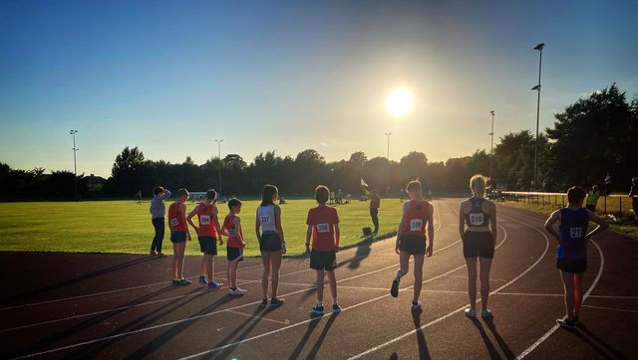

Charity Contact information
Harmeny Athletic Club
Scottish Charity Number: SC048917
28 Baberton Mains Green, Edinburgh
EH14 3EJ

07983 229 177
harmenysec@gmail.com
Website harmenyac.org

Charity Trustees

- Susan Ross - Chairperson
- Mairi Wallace (replaced Mark Jones) - Treasurer
- Phil Buckley (replaced Darren Cavaroli) – Vice Chair and Runners Council rep
- Sam Denis – Membership Secretary
- Elaine Walker – Board Member
- John Pringle – Board Member
- Craig Stewart - Club Secretary & Junior Representative
- Kim Kenny – Board Member & Jog Scotland Representative

Objectives and activities
The Club will operate as a non‐profit distributing charity whose principal objectives are:
- The advancement of public participation in Athletics as a sport;
- To provide recreational facilities and/or organise recreational activities, available to members of the public at large, with the object of improving the conditions of life;
In furtherance of the above shall:
- Provide a base for successful competitive track and field athletics and country running and to develop the full potential of each member;
- Encourage enthusiastic instructors, coaches, officials and administrators within the club and provide opportunity for qualification and experience; and
- Provide a base for non‐track and field runners and those wishing to run as a recreational activity or to improve their general fitness
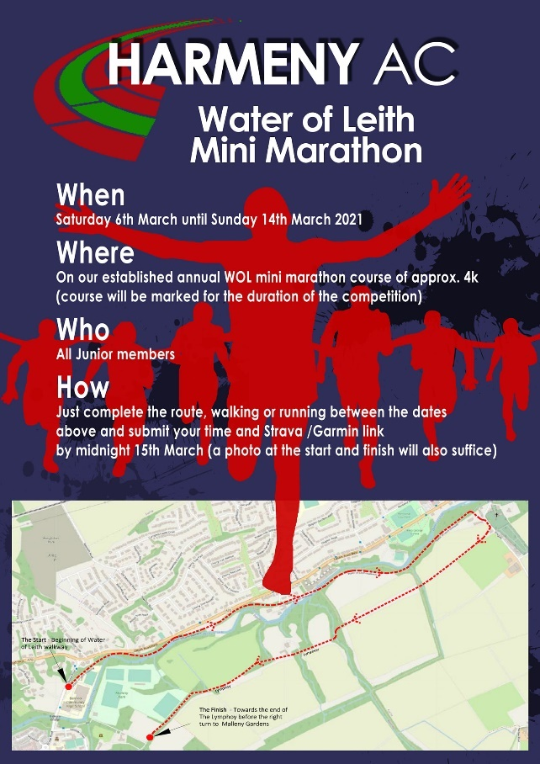
The club continues to support its objectives by providing further opportunities for its members to train in a friendly and supportive environment. Although lockdown restrictions severely hampered our club activities over the past 12months, we have bounced back in an innovative way:
- Welcomed people who are new to running through lockdown by offering different levels of club run – initially started on a Sunday morning, but now rolled out for Wednesday runs too;
- All the pre-pandemic training sessions have now been re-established;
- Junior training has been amongst the first to return post 2nd lockdown, and has expanded to now offer Run, Jump and Throw clubs to 7-9 year olds.
- Hosted the first ever Lothian cross country series race at Holyrood park, providing competitive opportunities to junior athletes from across the Lothians;
- Hosted the first ever licensed track and field meetings at Saughton Sports Centre, including electronic timing and photo-finish.
- Junior athletes have been more active in regional and national competition than ever before.
- We offered both Easter and Summer holiday camps and were able to fund free places for those on low incomes and had great engagement with kids from the refugee community through ScoreScotland charity, several of whom have since joined the club as members.

Structure, governance and management
Type of governing document
In 2018 the club members voted to accept a new club constitution which had been written with the support of a Scottish Athletics funded lawyer. In parallel to this, the club applied to the OSCR to become a Scottish Incorporated Charitable Organisation (SCIO). The application was accepted on 9th December 2018.
The Board of Trustees currently numbers 8. The constitution allows for between 5 and 12 members. The core roles of the Board are: Chairperson, Secretary, Treasurer, and Welfare Officer. The Board also currently contains a Vice Chair and Membership Secretary plus 2 other Board members.
The affairs of the adult running section are overseen by the Runners Council and the junior section by the Coaches & Team Managers. No other sub-groups currently exist.

Trustee recruitment and appointment
Darren Cavaroli and Judith Campbell both resigned from the Board at the AGM in 2020. Darren is still heavily involved with the club as coach amongst other background tasks club records and assisted membership. Darren was replaced by Phil Buckley as Vice Chair and representative of senior club.
Judith Campbell also resigned after 9 years as Child Welfare Officer. Judith has been replaced by Angela Lawson as CWO, however Angela has chosen not to take a place on the Board of Trustees.
Shortly after the AGM in 2020, Mark Jones resigned as Club Treasurer and the Board appointed Mairi Wallace to replace.

Achievements and performance
2020-21 Report Stated Priorities
With so much uncertainty, the objectives for 2020-21 set out in the 2020 Annual report were cautious and conservative, mainly a carry forward of core club strategy.
Numbers of members continued to grow and opportunities to train were provided whenever government covid regulations allowed. Harmeny were generally recognised as one of the most innovative and progressive clubs when it came to engagement with members during the pandemic, recognised by our short-listing for ‘Innovation of the Year’ award from Scottish Athletics.
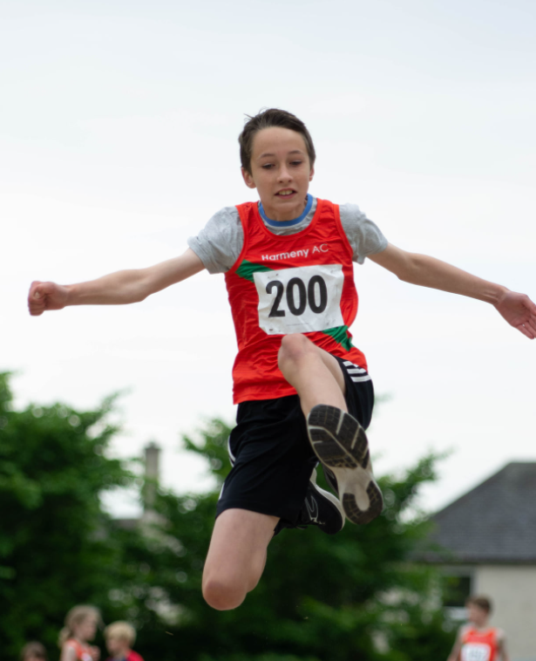
Our volunteer and coaching base also continued to grow, with 2 young (16) athletes now ready to start their qualifications. Online courses were provided for new Track Officials, and with the recently certified Saughton track hosting 3 SAL licensed events for the first time in its history, officials had plenty of opportunity to gain experience.
Our Inactive-to-Active objective continued with further successful JogScotland courses being run and a phenomenally successful ‘conversion’ from these to full membership with many taking part in the first seniors club event for some time, the Water of Leith Handicap. The Board have also sanctioned a new employed-role; Adult Recruitment co-ordinator who will seek to bring more new runners into the club. Funding for this role Is currently being applied for.
Our engagement with local schools came to an abrupt ending with Active Schools only recently starting up again. However, continued support for community groups including Clovenstone community centre, Score Refugee charity and disability athletics mean that the employed coaching officers have kept themselves busy nonetheless.
Finally, we saw our first foray into competition for older (U17/20) athletes as Harmeny joined ‘Team Edinburgh’. Although the Scottish Athletics Junior League didn’t take place this year, a number of meets, in conjunction with the senior leagues, provided high-class competitive opportunities.

Off-field Achievements
Despite the impacts of the pandemic, Harmeny have had a fantastic year, and have been innovative in their approach to engagement with members, volunteers and the local community alike. This has resulted in a 10% increase in membership over the year, while additionally widening their engagement with the local community with events such as:
- 7Reservoirs Virtual Half Marathon (288 runners) and Virtual Rigg Race
- Jog Scotland courses (55 participants, including a new partnership with Heriot Watt University),
- Easter and Summer camps for kids (40 non-members joining our existing members, including more than 20 from local refugee charity Score).

Harmeny’s biggest achievement, however, has been in bringing together the Lothian athletics community firstly to return safely to training at Saughton, and later to provide competitive opportunities for kids, at a time when most competitions were being cancelled due to bubble and travel restrictions. The first of these was the Lothian Junior XC events at Holyrood and then Foxlake in Autumn 2020 - over 130 junior athletes took part from 5 different clubs. A further event at Heriot Watt university will take place in September 2021 with an expanded number of clubs (14) taking part.

Harmeny volunteers gathered those same clubs together in May and June to deliver 2 Lothian Together Apart Series and a Middle Distance race night, utilising Saughton Track in Edinburgh as a Level 1 licensed venue for the first time in its history.

We had zoom calls on nutrition, online quizzes, designed new clubwear and gave away hundreds of Harmeny-branded buffs to our members. In December we started a club 50/50 lottery to expand our Assisted Membership Scheme, meaning we have been able to engage more athletes in hard-to-reach areas, including the refugee community, by providing free or heavily discounted membership and training so that no-one will lose an opportunity to participate due to lack of funds.

2 ‘virtual’ events were organised for the adult membership: one 5k at Cramond and one at Oriam.

When restrictions eased a little in October, we recognised that many people had taken to pounding the streets during lockdown. So we transformed our recreational running approach to encourage both new and existing members to continue running in a covid-safe manner, by offering distance, speed and route options to suit everybody. This resulted in the best club run turnouts for many years. It’s reinvigorated the club in a way we never thought possible.

In January 2021 we encouraged younger members to meet up with a friend to train together until groups were allowed again. And in April we had a virtual Water of Leith mini marathon (for juniors) and opened this up to Edinburgh AC and Corstorphine AAC. We had over 50 entries with some completing the course more than once to try for a better time. And then in August we were able to have our first senior event, again on the Water of Leith with a record number of new members turning out to take part.

Overall, the response from members has been amazing with many members commenting that they feel the most engaged they have been for years. As we move into the lowest levels of restrictions, we intend to keep this up for a long time to come!
Easter & Summer Camps

We have successfully applied for Gift Aid for the first time and have been awarded various financial awards to assist in Covid recovery.

We took part in “An Evening with Josh Kerr” where many juniors, and a few seniors, were inspired by Edinburgh’s recent Olympic Bronze Medallist – the kind of evening and event that will last with everyone who attended for years to come.

Craig Stewart was recognised by being awarded an honorary life membership for his work for the club over a 10-year period and specifically for his help during the pandemic.

Finally, the club was shortlisted for Scottish Athletics Impact Club of the Year in 2021 for the 3rd time in 5 years as well as the new (for Covid) award of Innovation of the Year. The Awards will be announced on 9th October at the annual awards ceremony.

Membership Statistics
Membership Group | 2020/21 | 2019/20 | 2018/19 | 2017/18
Members
Senior members | 210 | 201 | 167 | 135*
2nd claim | 4 | 3 | 4 | 2
Active Junior members | 218 | 188 | 173 | 162
Inactive Junior members (left during the year) | 77 (Not included in total) | 55 (Not included in total)
Total | 432 (up 10%) | 392 (up 14%) | 344 (up 15%) | 299
Coaches & Officials (Active)
Level 3 (Event Group) | 6 | 4 | 4 | 3
Level 2 (Athletics Coach of CIRF) | 4 | 7 | 5 | 3
Jog Scotland Leaders | 12 | 12 | 8 | 12
Level 1 (Coaching Assistant) | 11 | 8 | 11 | 4
Other | 6 | 8 | 1 | 0
Officials – Qualified | 9 | 2 | 2 | 1
Assistant Officials | 7 | 6 | 5 | 0

The junior section continues to grow and, crucially, progresses its target of retaining athletes through older age categories. We also still have a significant waiting list of more than 60 kids.
Sept 2021 | Total | U9 | U11 | U13 | U15 | U17 | U20
Girls | 82 | 5 | 29 | 28 | 16 | 4 | 0
Boys | 105 | 6 | 35 | 35 | 16 | 11 | 2
Total | 187 | 11 | 64 | 63 | 32 | 15 | 2
Sep 2022

Female | 98 | 7 | 19 | 34 | 26 | 10 | 1
Male | 122 | 7 | 17 | 47 | 29 | 11 | 10
Total | 218 | 14 | 36 | 81 | 55 | 21 | 11
+/- | +30 | +3 | -28 | +18 | +23 | +6 | +9

Junior on-field achievements
Cross Country & Trail
Lindsay’s Scottish athletics Invitational< Scone
- U15 Boys - 1st Place Finlay Ross
- U13 Boys - 3rd Place Fergus Ross, 4th Place Matthew Holden
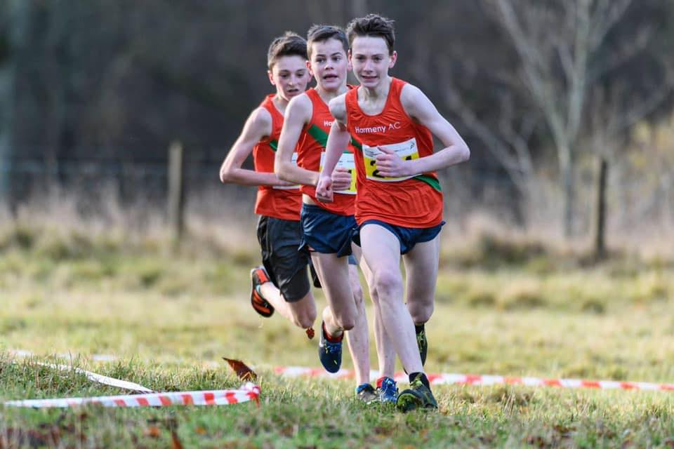
Track & Field
National Champs, Aberdeen
- U13 Boys 100m Bronze – Alex Columbine-Green
- U13 Boys 1500m Gold – Fergus Ross
National Relay Champs, Linwood
- U13 Girls 3x800m Gold - Nancy Corrie, Emilie Paul, Leah Buchan
- U13 Boys 3x800m Silver – Fergus Ross, Fergus Roberts, Daniel McIntyre
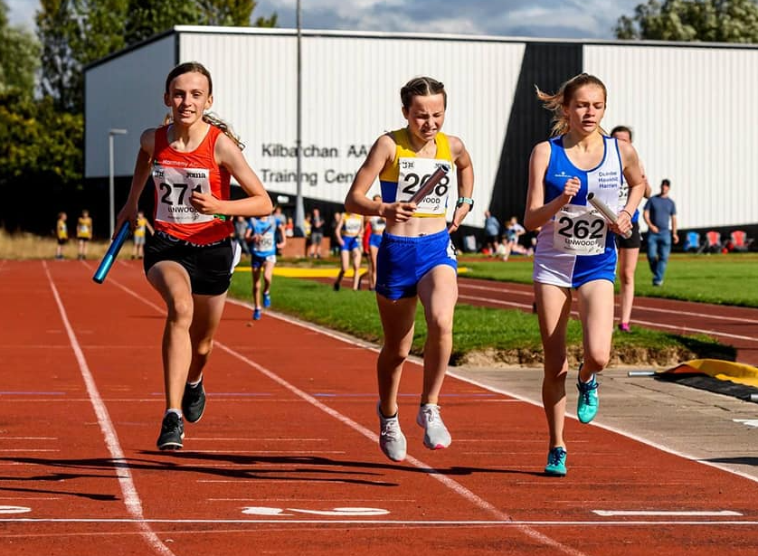
Club Awards (2020)
Male Athlete of the Year: Fergus Ross
Female Athlete of the Year: Lucy McDonald
Competitor of the Year: Olivia Faith Muir
Best Performance: U15 Boys Team
Endeavour Award: Ben Paterson

Club Records
U20b 100m Calum Ridgway 12.44s
U20b 200m Calum Ridgway 25.83s
U17b 1500m Tendai Nyabadza 4m 02s
U17b 3000m Tendai Nyabadza 8m 57.3s
U13b 800m Fergus Ross 2m 15.1s

U13g 3x800m relay 7m 49.14s (Leah Buchan, Emilie Paul, Nancy Corrie)
U15b 4x100m relay 50.06s (Euan Laird, Noah Ralph, Ben McDonald, Cameron Weir)
Parkrun 5k JM15-17 Alasdair Wallace 16m 38s
Parkrun 2k JW11-14 Nancy Corrie 7m 18s

Adult Achievements
The past year has obviously seen many challenges for the club and all its members due to the ongoing COVID pandemic which curtailed training, social gatherings, the Grand Prix and races for long periods. But, despite all of this, the club has survived and indeed grown and flourished. As we emerge from the pandemic it has been great to see the smiles back at club runs and races and I’m sure we all hope that we can all continue to move onwards and upwards from here.
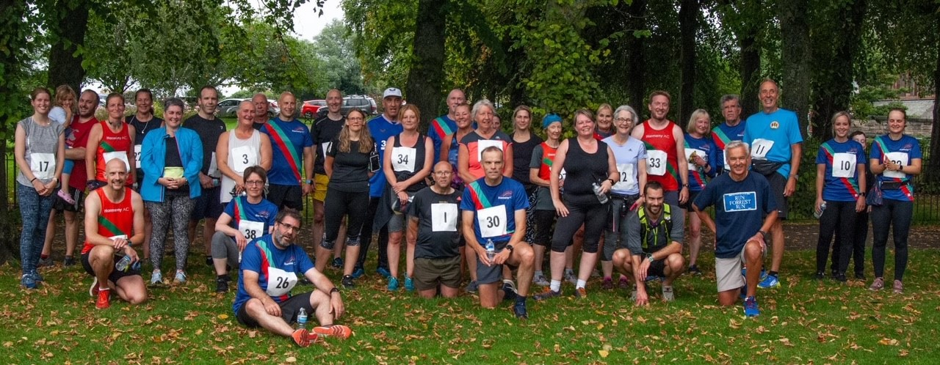
Performance
Fastest times over recognised distances:
Marathon – Male – Phil Buckley – 3:04:28 (Boston UK – May)
Marathon – Female – Kim Kenny – 3:45:33 (Boston UK – May)
Half Marathon – Male – Phil Buckley – 1:21:51 (Scottish Half – September)
Half Marathon – Female – Kim Kenny – 1:43:48 (Scottish Half – September)
10k – Male – Damien O’Looney – 35:48 (Blast 10k – June)
10k – Female – Nicky Freedman – 46:23 (City of Stirling 10k – September)
5k – Male – Phil Buckley – 17:20 (Blast Meadows – October)
5k – Female – Elaine Walker – 20:56 (Blast Meadows – June)

There have been some notable performances and achievements over a range of distances also:
Lindsay Cockburn was 4th at both the Glen Ogle and Tiree Ultras. Phil Buckley also grabbed 4th spot at the Run the Blades Ultra. Continuing the theme Angus Kay came in 4th at Glen Lyon in June, with Pam Williams also performing very well in that event too. Angus also had a very creditable 11th place finish at the Speyside Way 35 miles in August.
Allan Price has been out on tour with some great performances at the Cairngorms 62k, Solway Coast Marathon, Alnwick Castle 10k and Shropshire Way 50 mile. Also on their travels have been Keith Martin at the Durisdeer Hill Race and Dollar Hill race, Paul Campbell with a great time at the Strathearn Marathon, Donald and Elaine Sandeman at the Splash N Dash in St Andrews, Pat Hampton at the Path of Condie Half, Donald S again with a great run at the Blast Sunset marathon, Martin Lyall and Anne Enneguess at the Glencoe Half, Keith Lyle at the Great North Run and Craig Stewart at the Alnwick Trail 10k.
Mention also to Dougie Porteous for a top showing in the very tough Lairig Ghru race, Pam Williams at the Great Glen Ultra and Glen Ogle, Susan Law at the Kintyre Way Ultra and Lorna Broadhurst at the Lakes Sky 55km.
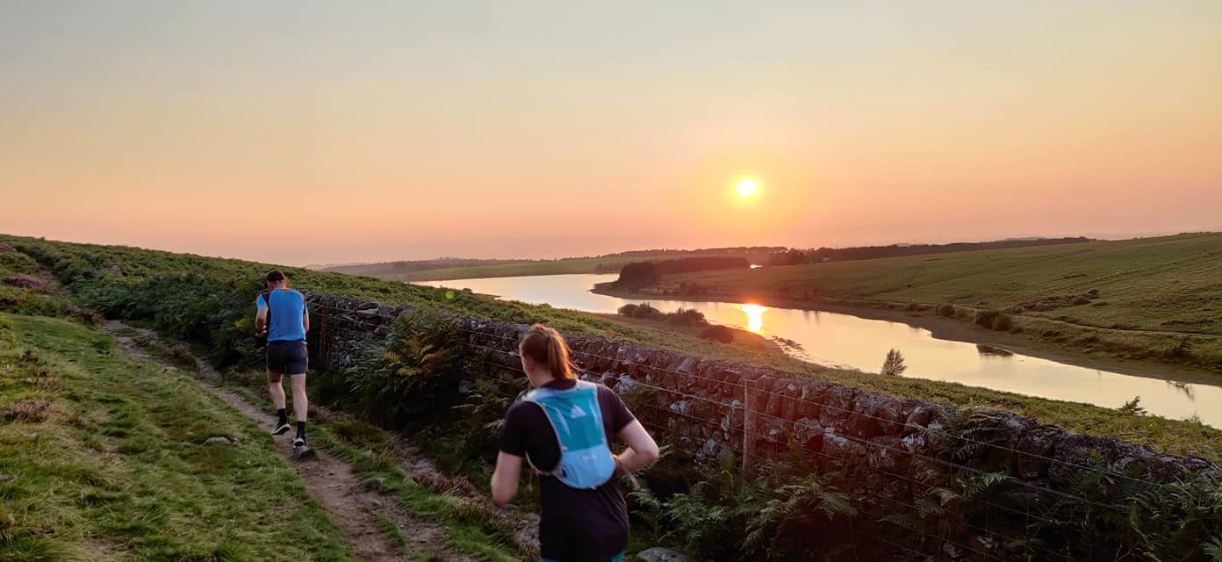
A special shout out to Sam Walsh for 2 amazing runs this year. Firstly, achieving the Fastest Known Time on the 108-mile Ayrshire Coastal Path in June and then a superhuman effort in the 215-mile Race Across Scotland in August. A truly epic run!
It was great to see good turnouts from the club at the 7 Hills of Edinburgh Challenge and Race in June, the Scurry to the Sea Event in July, the Dalmeny Half and 20 miler in May and the Kips Race in June and most recently the Scottish Half marathon and inaugural Conic Canter event.
All this goes to show that things appear to be returning to some sort of normality!
Grand Prix Event
Sadly, due to a lack of races there will be no Grand Prix 2021 awards this year – but work is just starting on the events for 2022 – so look out for those.
Congratulations to our winners from 2020:
Male
- Keith Martin
- Simon Watkinson
- Dougie Porteous
Female
- Anne Douglas
- Elaine Sandeman
- Julie Watkinson

Rigg Race and 7 res
Due to COVID both these races were run as virtual events and it was great to see so many club members taking part and some excellent performances:
Rigg Race
Male
- Phil Buckley (2nd overall)
- William Gorol (1st over 50)
- Dougie Porteous (1st over 40)
Female
- Kim Kenny (1st Female overall)
- Anne Douglas
- Pamela Lorimer
7 res
Male
- Iain Hutchison
- Lindsay Cockburn
- Philip Holden
Female
- Genevieve Harborrow
- Julie Sanders
- Elaine Walker
The good news is that the 7 res will be run as a proper event this year on Sunday December 5th which will be a great Club event as always – and a Virtual Option is also being offered for those who miss out on entry. And fingers crossed the Rigg Race will be back as normal in May 2022.
Club Handicap Race August 2021
We were delighted to have a proper, not virtual, Handicap Race just a few weeks ago on 29th August which attracted 34 runners, many of them first timers – so well done to all for taking part. And congratulations to Philip Holden and Kim Kenny for the fastest times, and to Peter McGavigan and Ingird Butler for being first over the line.
Other Virtual Events
In December we held a virtual 5k race using the Oriam Heriot Watt parkrun route which attracted 45 runners. Well done to Susan Irwin and Ian Smith as fastest lady and man.
We also did the same during the first quarter of this year using the Cramond parkrun course which was arranged by Elaine Walker. Congrats to Elaine and Iain Hutchison for grabbing top spots in this event.
Cross Country
Sadly due to COVID there was no Cross Country last year but it’s back this year! So it would be great to see as many members as possible racing in the club colours.
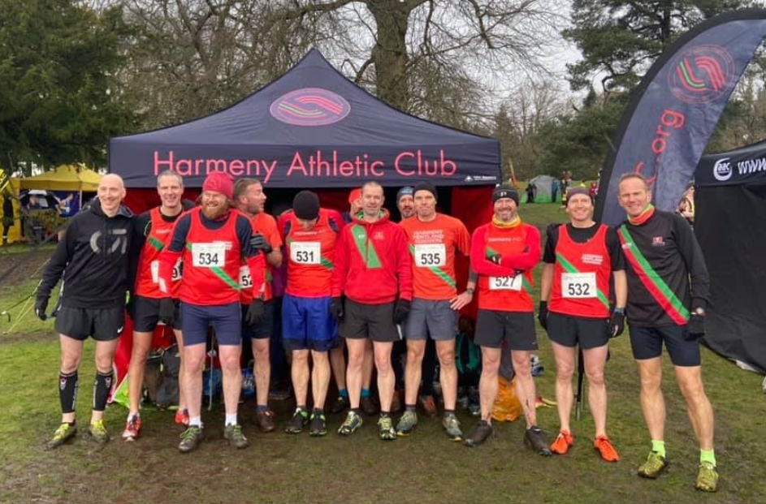

Jogscotland
We ran 2 very successful jogscotland groups on a Wednesday in conjunction with Oriam and on a Sunday from Balerno, culminating in a timed 5k on the Oriam parkrun course on 1st August with 24 runners taking part and a great turnout from the club to support and put on the event. From this intake of graduates, we have 20 new members in the club and are continuing to support and develop their running on the Group C runs on a Wednesday and Sunday. Many thanks once again to Kim Kenny for all her efforts with jogscotland and to all the run leaders and helpers who gave up their time.
Training
Club training was heavily curtailed through the year but in recent months all of our sessions have been getting back to normal. Thank you to Ian Beattie with his continued efforts for the Tuesday Night Group, and to Nicky Freedman and Darren Cavaroli for their fun and enthusiastic Thursday track sessions.
Sunday runs have been growing well with 3 groups now meeting every Sunday at 9.30am and possibly a need for a 4th group now. Many thanks to Elaine Walker and the various run leaders for all their efforts.
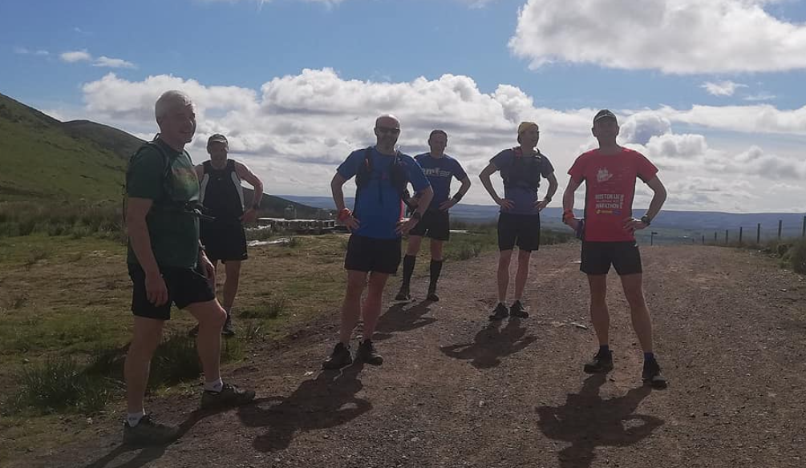
Wednesday night headtorch runs are also back – many thanks to Dougie Porteous for co-ordinating these and we’re hoping to offer at least 2 options every week.

Social
Again, COVID has not been our friend and has prevented any gatherings or plans for a trip away. Hopefully, however, we may be able to organise a Christmas get together of some sort for this year – so look out for this.
Finally, a huge thank you to all of our members who have contributed over the last 12 months and supported one another through these difficult times. I’m sure I’m not alone in saying that running has been a tremendous outlet and boost for us all, even with the lack of races - but just lacing up those shoes and getting out into the fresh air and pounding the tarmac or getting up into the fresh air in the hills gives us all a great sense of wellbeing and happiness.
Thanks!!!
Many thanks once again to the incredible number of volunteers (well over 60!!!!) and coaches who, together, make Harmeny the incredible club that it is…
Board  Susan Ross  Phil Buckley  Sam Denis  Elaine Walker  John Pringle  Craig Stewart  Mairi Wallace  Kim Kenny  Junior Coaching  Derek Johnstone  Lorraine Boyd  Ryan Kyle  Andy Ross  Stephen Buchan  Lyndsay Holden  Jane Leask  Pam Lorimer  Graeme Stewart  Craig Stewart  Jonathan Kennedy  Juliet Gold  Grainne Morrison  Marco Lam  Ethan Lorimer  Kim Wilson  Liam Clark  Nicky Freedman  Alison Broadhurst  Kevin Kealy  Sophie MacGillivray  David Alexander  Allan Hardie  Photography  Mike Taylor | Senior Coaching  Darren Cavaroli  Ian Beattie  Nicky Freedman  Jog Leaders  Kim Kenny  Adrian White  Anne Douglas  David Syme  Nicky Freedman  John Pringle  Jackie Pringle  Wendy Cunningham  Elaine Sandeman  Claire Cunningham  Anne Enneguess  Lesley Muego  Carol Blamire  Adult Race/Event Directors  Donald Sandeman  Damien O’Looney  John Pringle  Website, SAL, Club Records, Race Results, Welfare  Susan Ross  Chris Haworth  John Smith  Angus Kay  Ian Smith  Darren Cavaroli  Donald Sandeman  Karen Marshall  Lesley Rowand  Angela Lawson | Team Management  Andy Ross  Mike Taylor  Nick Green  Lyndsay Holden  Nicola McGuire  Michaela Muir  Susan Ross  Officials  Nick Green  Lyndsay Holden  Karen Marshall  Susan Ross  Mike Lynch  Lorraine Boyd  Sarah Corrie  Susan Irwin  Annja Louca  Michelle McLeod  Joe Melton  Craig Paul  Catherine Pierce  Michaela Muir  Adult Run Leaders  Elaine Walker  John Pringle  Dougie Porteous  Paul Campbell  Phil Buckley  Kim Kenny  Donald Sandeman  Pam Williams  David Syme

Financial review/Treasurer’s Report
A full, audited set of accounts to be completed with the Club’s end of year report for the OSCR.
The accounts have been prepared in a Receipts and Payments basis (no accruals). Income and payments are accounted for at the time of presentation.
In summary, last year’s accounts, to Aug 2020, incurred a deficit of £1,263 due to the Covid lockdown that caused a loss of 8months income. This year, however, has shown the resilience of the club not only to recover but to have a surplus of £11,395….1 ½ times greater than Aug 2019.The bank balances are standing at a healthy £51,089 at this year-end.
Receipts up circa £24K
- Membership receipts up £1,634
- Training fees income increase by £6,457- We trained for more of the year this year (shorter lockdown), we had more kids and we increased the charge for training.
- Plus income from holiday camps £3,934
- Sports Clothing increase –training tops accounted for most of this. This year a profit of £367 against a loss last year of £200.
- Donations were a big source of income this year, especially compared to previous years, we received the following:
  - £500 from BoS – Matched Funding for Craig Stewart’s 2020 volunteering hours – likely to be repeated
  - £384 from BoS – Matched Funding for Stephen Buchan’s 2020 volunteering hours– likely to be repeated
  - £500 from BoS – Matched Funding for Craig Stewart’s 2021 volunteering hours – got this twice this financial year
  - £1,450 from SAMH for running Summer Camps – one-off and won’t be repeated.
  - £800 from Edinburgh Council for running Summer Camps – one-off and won’t be repeated
  - £500 from Edin. Council to purchase equipment (javelins and med balls) and won’t be repeated
  - £3,250 from SportScotland/Lottery – agreed funding for Club Development Officers year 4 of 4.
  - £3,000 from Foundation Scotland – one off donation
  - £1,713 – Gift Aid from HMRC – will be repeated
  - A total of 12,097 up 3x on last year and 2x on 2019.
- Prize fund/50:50 made a profit of £250
- Rigg race had a good return this year of £2,578
- Assisted Membership contributions came into effect in March and already people have contributed via Loveadmin £239
Payments up circa £11.5K
- Facilities fees of £11,303– reflects the fact that we pay for more hours from Edin. Leisure and fees have increased. We also paid for easter and summer camps (4 weeks in total). Plus, we trained for more of the year (shorter lockdown).
- Coaching fees this year also include the cost of the courses our coaches attended and the total expense is up by £2.6K. Next year they will be accounted for separately.
- We were able to use £65 in the assisted membership scheme to help attendance at events and we donated £405 to charity.
- We were able to buy £2.7K of equipment up £1k from last year.

I am pleased to report that Harmeny Athletics Club is in a good financial position to support itself through 21/22.

Statement of the charity’s policy on reserves
In 2020 the Board agreed to hold a £10,000 reserve. It was felt this number would comfortably cover any costs associated with the cancellation of one of our flagship races and extraordinary one-off costs. This amount is being held in a separate bank account.

Income and Expenditure Account

 |  |  |  |  |  |  |  | Full year
 | Item |  | Year to 31/8/21 |  |  |  |  | Year to 31/8/20
Receipts |  |  | £ |  |  |  |  | £
 | Memberships |  | 9,996.00 |  |  |  |  | 8,362.40
 | Training fees |  | 21,865.06 |  |  |  |  | 15,407.96
 | Adult Social |  | - |  |  |  |  | 20.00
 | Sports Clothing |  | 3,844.50 |  |  |  |  | 468.11
 | Rigg Race |  | 2,578.00 |  |  |  |  | 907.25
 | 7R Half Marathon |  | 688.25 |  |  |  |  | 2,750.40
 | Race/Track Fees |  | 1,256.00 |  |  |  |  | -
 | Prize Fund |  | 558.00 |  |  |  |  | 456.86
 | Kids Camps |  | 3,934.00 |  |  |  |  | 583.62
 | Kids Socials |  | 780.00 |  |  |  |  | 448.44
 | Donations |  | 12,097.01 |  |  |  |  | 4,250.00
 | Assisted Membership |  | 239.00
 | Easy Fundraising |  | 138.22 |  |  |  |  | 199.00
 | Misc |  | 16.77 |  |  |  |  | 3.20
 | Total: |  | 57,990.81 |  |  |  |  | 33,857.24
Payments
 | League/SAL Fees |  | 7,327.00 |  |  |  |  | 3,638.00
 | Coaching/Courses |  | 17,148.00 |  |  |  |  | 14,464.75
 | Facilities |  | 11,303.35 |  |  |  |  | 7,710.94
 | Training fee refunds/Camps |  | 338.50 |  |  |  |  | 1,072.00
 | LZ Charges |  | 1,072.81 |  |  |  |  | -
 | Kids Socials |  | 680.00 |  |  |  |  | 1,179.50
 | Assisted Membership |  | 63.29
 | Donations to Charity |  | 405.00 |  |  |  |  | 1,050.00
 | Equipment |  | 2,715.08 |  |  |  |  | 1,714.09
 | Sports Clothing |  | 3,477.39 |  |  |  |  | 677.01
 | Adult Socials |  | 57.13 |  |  |  |  | 1,145.05
 | Postage |  | 11.24
 | 50/50 Lottery |  | 221.00 |  |  |  |  | 22.00
 | Rigg Race |  | - |  |  |  |  | 907.25
 | 7 R's |  | 955.94 |  |  |  |  | £ 605.50
 | Web/Adverts |  | 74.33 |  |  |  |  | 289.04
 | Race Fees |  | 516.50
 | Audit |  | 42.58
 | Misc. |  | 178.17
 | Membership Refunds |  | - |  |  |  |  | 646.00
 | Total: |  | 46,587.31 |  |  |  |  | 35,121.13
Surplus/(deficit) for year |  |  | 11,401.50 |  |  |  |  | (1,263.89)
Balance Sheet |  |  |  | Year to 31/8/21 |  |  | As at 31/08/20
 |  |  |  | £ |  |  | £
Cash at Bank and in Hand |  |  |  | 51,089.77 |  |  | 39,688.22
 |  |  |  | 51,089.77 |  |  | 39,688.22
Represented by:
Retained surplus/deficit brought forward |  |  |  | 39,688.22 |  |  | 40,952.11
Surplus/Deficit for year |  |  |  | 11,401.50 |  |  | (1,263.89)
 |  |  |  | 51,089.72 |  |  | 39,688.22

Future plans
We’re all hoping that 2021-22 will be a far more ‘normal’ year. There are great opportunities for clubs such as Harmeny to contribute to the post Covid recovery, helping people’s mental and physical health. Some of the initiatives that are currently being considered are:
- The Board of Trustees recently agreed to employ a 4-hour per week role to help engage more adult members, especially in hard-to-reach populations. Funding for this role has been applied for and an appointment is expected to be in place before the end of 2021.
- There will also be challenges ahead. State and council funding for sports facilities, especially in Edinburgh, is hard to come by and the facility at Saughton requires a significant upgrade. The club are investigating, along with Corstorphine AAC, the possibility of taking on the lease of the Saughton Enclosure from Edinburgh Council in order to help obtain funding to improve the facility and secure its future as an athletics facility.
- The Board are also currently in discussions with the Edinburgh Eagles Disability Athletics Club about how we can support them and secure their future, possibly by becoming another ‘branch’ of Harmeny.
- Finally, Lockdown and Covid restrictions resulted in the club leading the way in organising events for juniors in a Covid-safe way. However, in future we will consider holding events that will both be engaging and income-generating for the club.
While our long-term goals of supporting existing members while expanding both junior and senior sections of the club remain a priority and we will explore new and innovative ways of achieving this.

Declaration
Signed on behalf of the charity trustees:

Print name

Designation

Date

